

**American International University- Bangladesh**

**COE 3103: DATA COMMUNICATION**

**Final Lab Report 07**

**Spring 2021-2022**

**Section: I**

**Date: 12/04/2022**

**Submitted by, Group 03**

|  |  |
| --- | --- |
| Student Name | Student Id |
| Rahman, Sheikh Talha Jubayer | 19-41468-3 |
| Shifat, Mahabub Hasan | 19-41460-3 |
| Hasan, Sayeed | 19-41005-2 |
| Islam, Hasan Sanjry | 19-39589-1 |
| Durjoy, Md. Badrul Alam | 18-39248-3 |

**Tasks**

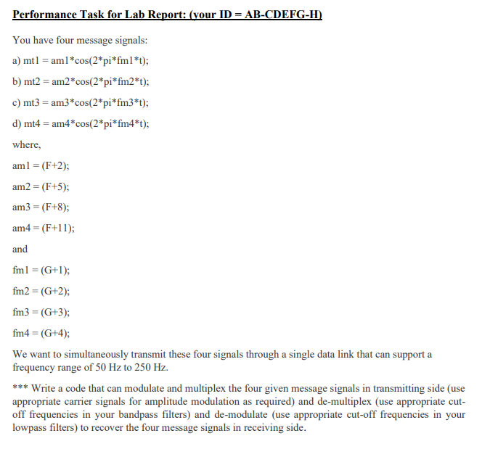

**Solution of Performance Task**

%ID: 19-41468-3